University of Lima
Faculty of Engineering
Civil Engineering Program

TITLE OF THE RESEARCH project
Thesis to opt for Professional’s Title in Civil Engineering

[Student ’s names and surnames]
Code [Insert student’s code]

Advisor
Advisor’s names and surnames

Lima – Peru
Click here or press to write the date
Title
Be brief and descriptive, highlighting the most distinctive features from your research work

Author(s)
xxxxxxxxx@aloe.ulima.edu.pe
University of Lima

Abstract: [Describe the research problem and justify its importance. The research’s purpose or objective must be explained, as well as the methodology used, and its main results or findings. It is recommended to write a maximum of 300 words and not include references].
Keywords: [List of keywords which represent the topics covered in the research. At least 5 topics must be placed].

INTRODUCTION
[This section presents the fundamentals about the research, a summary of the knowledge necessary to understand the importance of the research findings.
A structured analysis of the literature review, regarding the problem addressed; a sequence of the events that lead to the current situation in the research context; and the contribution to a particular knowledge area, limitations, and research questions.
Details about previous research that shape a theoretical basis or a meaningful background to the knowledge areas involved in the ongoing research are provided].

Figure 1.1.
Neuronal network model
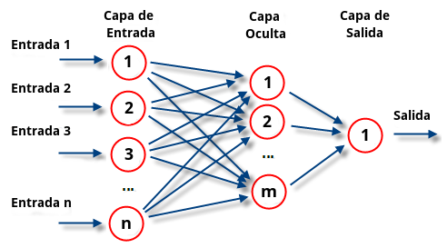
Source: Check the link:
http://contenidos.ulima.edu.pe/bibliofiles/gsu/formatos/Formato_tesis_ulima.pdf

MATERIALS AND METHODS
[This section describes the materials and methods that were used for the experiments and/or the ones used to carry out the research, in a detailed way, enough to allow others in field to continue and replicate the methodology. In addition, the population, the sample, and the research variables must be detailed].

Table 2.1.
Summary of breeds registered
Race | Quantity
Half Blood | 575
Siberian | 161
Terrier | 196
Schnauzer | 200
Boxer | 212
Shih Tzu | 65
Pug | 166
Labrador | 155
Shepherd | 103
Poodle | 68
Bulldog | 99
Source: Check the link: http://contenidos.ulima.edu.pe/bibliofiles/gsu/formatos/Formato_tesis_ulima.pdf

RESULTS AND DISCUSSION
[This section describes the results obtained from the research. The most emblematic results must be presented in this section. These results must be organized in a sequence that corresponds to the objectives, hypotheses, or research questions].
Obtained results’ interpretation and logical, critical, correct, and objective analysis are made, in comparison with the expected ones. The discussion is the results’ assessment, the explanation of the whys, based on their contrast with the literature review and theoretical framework].

Table 3.1.
Summary of breeds registered
Parámetro | Tipo de entrada | Rango | Detalle
Age | Continuous | 0-1 | Range from 0 to 10 years, more than 10 is considered as 10.
Sex | Binary | 0 o 1 | 0 is male and 1 is female
Breed | Continuous | 0-1 | The percentage is assigned regarding to all the breeds in the data.
Sun exposure | Continuous | 0-1 | Low (25%), regular (50%), higher (75%) and constant (75%) exposure
 |  |  | (continue)
(continuation)
Dermatitis | Binary | 0 o 1 | 0 does not has dermatitis and 1 has dermatitis
Albinism | Binary | 0 o 1 | 0 is not albino and 1 is albino
Source: Check the link enlace http://contenidos.ulima.edu.pe/bibliofiles/gsu/formatos/Formato_tesis_ulima.pdf

CONCLUSIONS
[In this section, the conclusions are formulated and supported, so that they respond to the stated objectives].
Suggestions are made for the next implementation phases of the research and new research projects in the line with the proposed].

REFERENCES
[This section presents an ordered relation, in order of appearance, of all the sources cited about the theme addressed in the research work. APA format must be used, and the sources are recommended to be 5 years old].

